University of Brighton
Computer Games

CI411 - Introduction to Game Programming 2025 -26

Portfolio: Workshops and Game Logs and reflection.
Module Leader: Steven Kilgallon

Name: Alexander Hilton

Student number: 25843472

Date Submitted: **********

Contents
Workshops  (Summary, readings and discussion) | Topics covered | Included
Lab 1 | Conditional Statements | Yes
Lab 2 | Loops | Yes-
Lab 3 | Functions | Yes
Lab 4 | Arrays | Yes
Lab 5 | Objects | y/n
Lab 6 | Objects Methods and Inheritance | y/n
Game (Planning and discussion) | Application taught topics in a game. | y/n
Reflection (10%) | REFLECTION on whole of Module. | y/n

Workshop |  | Themes: | Operators & Variables
Discussion of Workshop Activity

Introduction Workshop

Reflection

- Brief overview of what you have done this Workshop:
I created a Calculation tool what allowed the user to use equations such as PI,radius,area and circumference and included things such as If statements and floats
- What has been learnt from the process?
These would include:
Cout <<“” is used to create a command to send information/data to the player character.
- \n and endl are both used to create a new line of code however it’s not used in things like switch statements.
- Cin.clear resets the programme with the user interface if the user inputs something outside what is required for example one would give the radius with Missile Calculator alongside the other calculations.
- PlayerChoice:
This is a variable what tells the calculator the user has picked
If/break/switch statements.
Cin >> It places numbers into the variable like the radius with the cin >> radius.
- What could you have done better?:
Things what could be improved would be add more options in the future for different types of rockets and give them their own calculations.
- How can you use what you have learnt in making future games?:
The code in this can make something like uno with the different options available to the player.

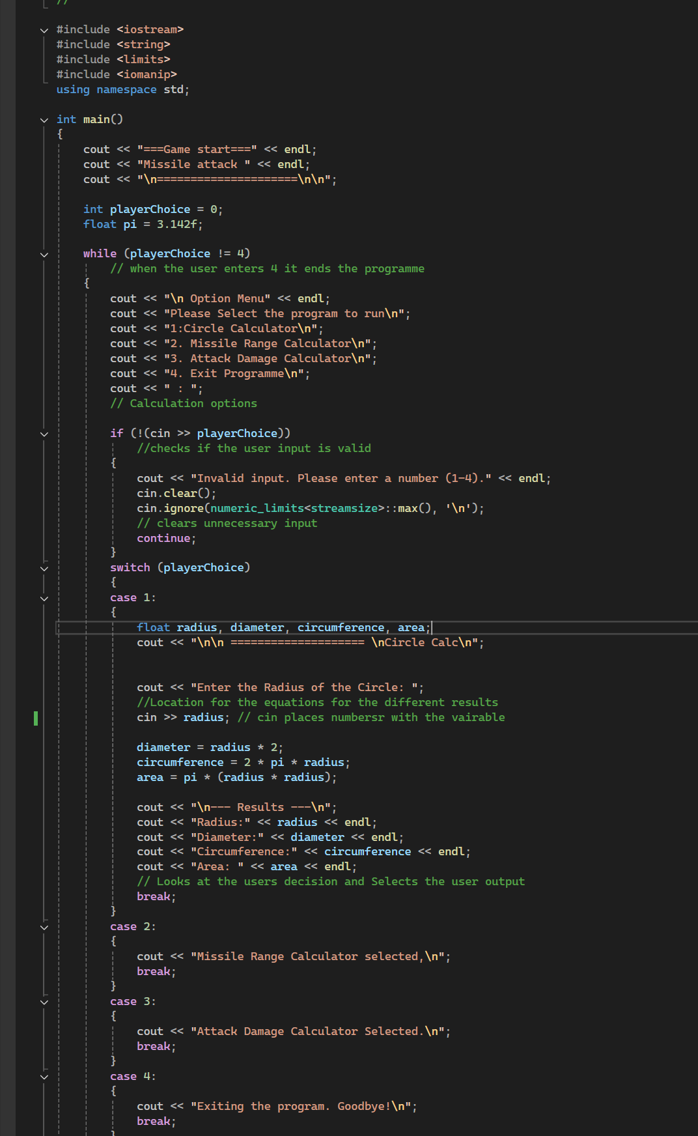
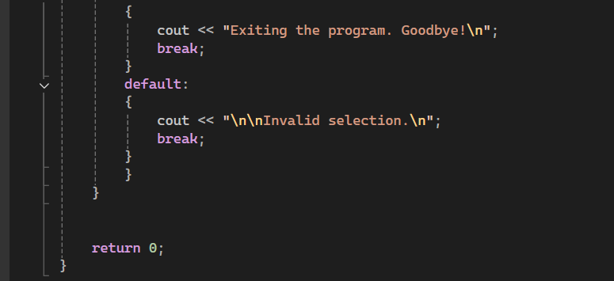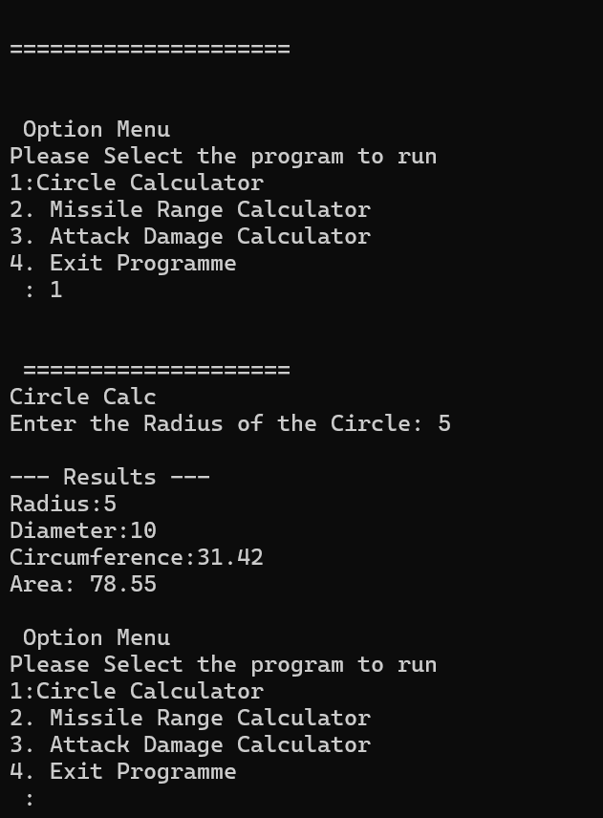

Conditional Statements Lab one
This workshop involved the creation of a character creating game what included a boss fight and let the player pick a character out of the three options being a warrior, Paladin and mage and this was done by using the code from the previous session with things like switches.
- What has been learnt from the process?
That you have to be careful that you don’t miss out on thing such as semi colons because it can get you syntax errors as well as remembering to include all the characters rather than just one or two.
- What could you have done better?:
I would expand upon it and create things such as mobs what the player can attack before fighting the main boss.
- How can you use what you have learnt in making future games?:
Like said previously you can use the code to create a larger scale of enemies or have a larger set of characters for the user to choose from.

Lab 2 Loops
- Brief overview of what you have done this Workshop:
Within the Workshop one of the objectives was to create a times table list up to 12 for example 10 to 120 and then afterwards I made it so that it would loop as many times the user wants to use the calculator.

Next part of the workshop was the creation of a game where the user has options like to be able to evade attack and defend.

Another part of the workshop is the creation of a loop regrading counting upwards from 1 to 20 and counting down from 100 to 0

For this part it was a creation of a random generated number.

- What has been learnt from the process?
That the process is similar to the other projects with the uses of things like for (int i = 1; i <= 12; i++) what limits the user up to the 12 variation of that number being times. And with the loop version I needed to include a char play again function

I learnt how to give the user multiple options to the user with calculations using rand() and that srand(static_cast<unsigned int>(time(0))); is needed for the numbers to be random and for each game to be different.

What was learnt was that you need a for loop each time you create a calculation or equation or give the console instructions to repeat what the user wants and that can be either with my examples be i++ counting up in ones or I -= 5 what is counting down in 5.

What I learnt creating a random number generator was that you need to have a srand(static_cast<unsigned int>(time(0))); each time and to give the user as many times as possible a go that would include using tries++ and that int secretNumber = rand() % 100 + 1; makes the number random each time as well.

- What could you have done better?:
I don’t think there is much else that could have been done better as its function is working correctly and with the updated version with the loop it’s the same feeling that my code works how it’s intended.

I feel like even though the code works how its intended its really bland in terms of there being no story unlike the previous variant with being able to choose a warrior, paladin and mage.

I don’t feel like there’s anything that could have been done better because the code is working as intended
- How can you use what you have learnt in making future games?:
With games I feel like this code could be used for something like ammunition with a shooting game or having a limit on the amount of rounds the enemy has before the player wins and this echos what I said espcailly adding the loop to the calculator up to 12 in any variation of numbers.
I feel like this code would be useful in terms of a RPG where the character collects loot and weapons and to give additional effects to the player like 5% extra speed.

The For (int feature I feel like can be use in games where the player has a timer before the player looses.

I don’t think there’s anything to improve upon even in terms of playing the code its not like its bland when youre guessing and its telling that you’ve either got it too low or too high or congratulates the player by getting the correct number.
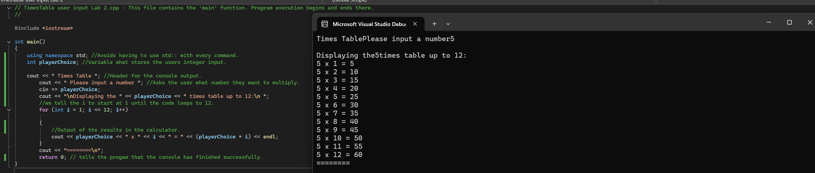

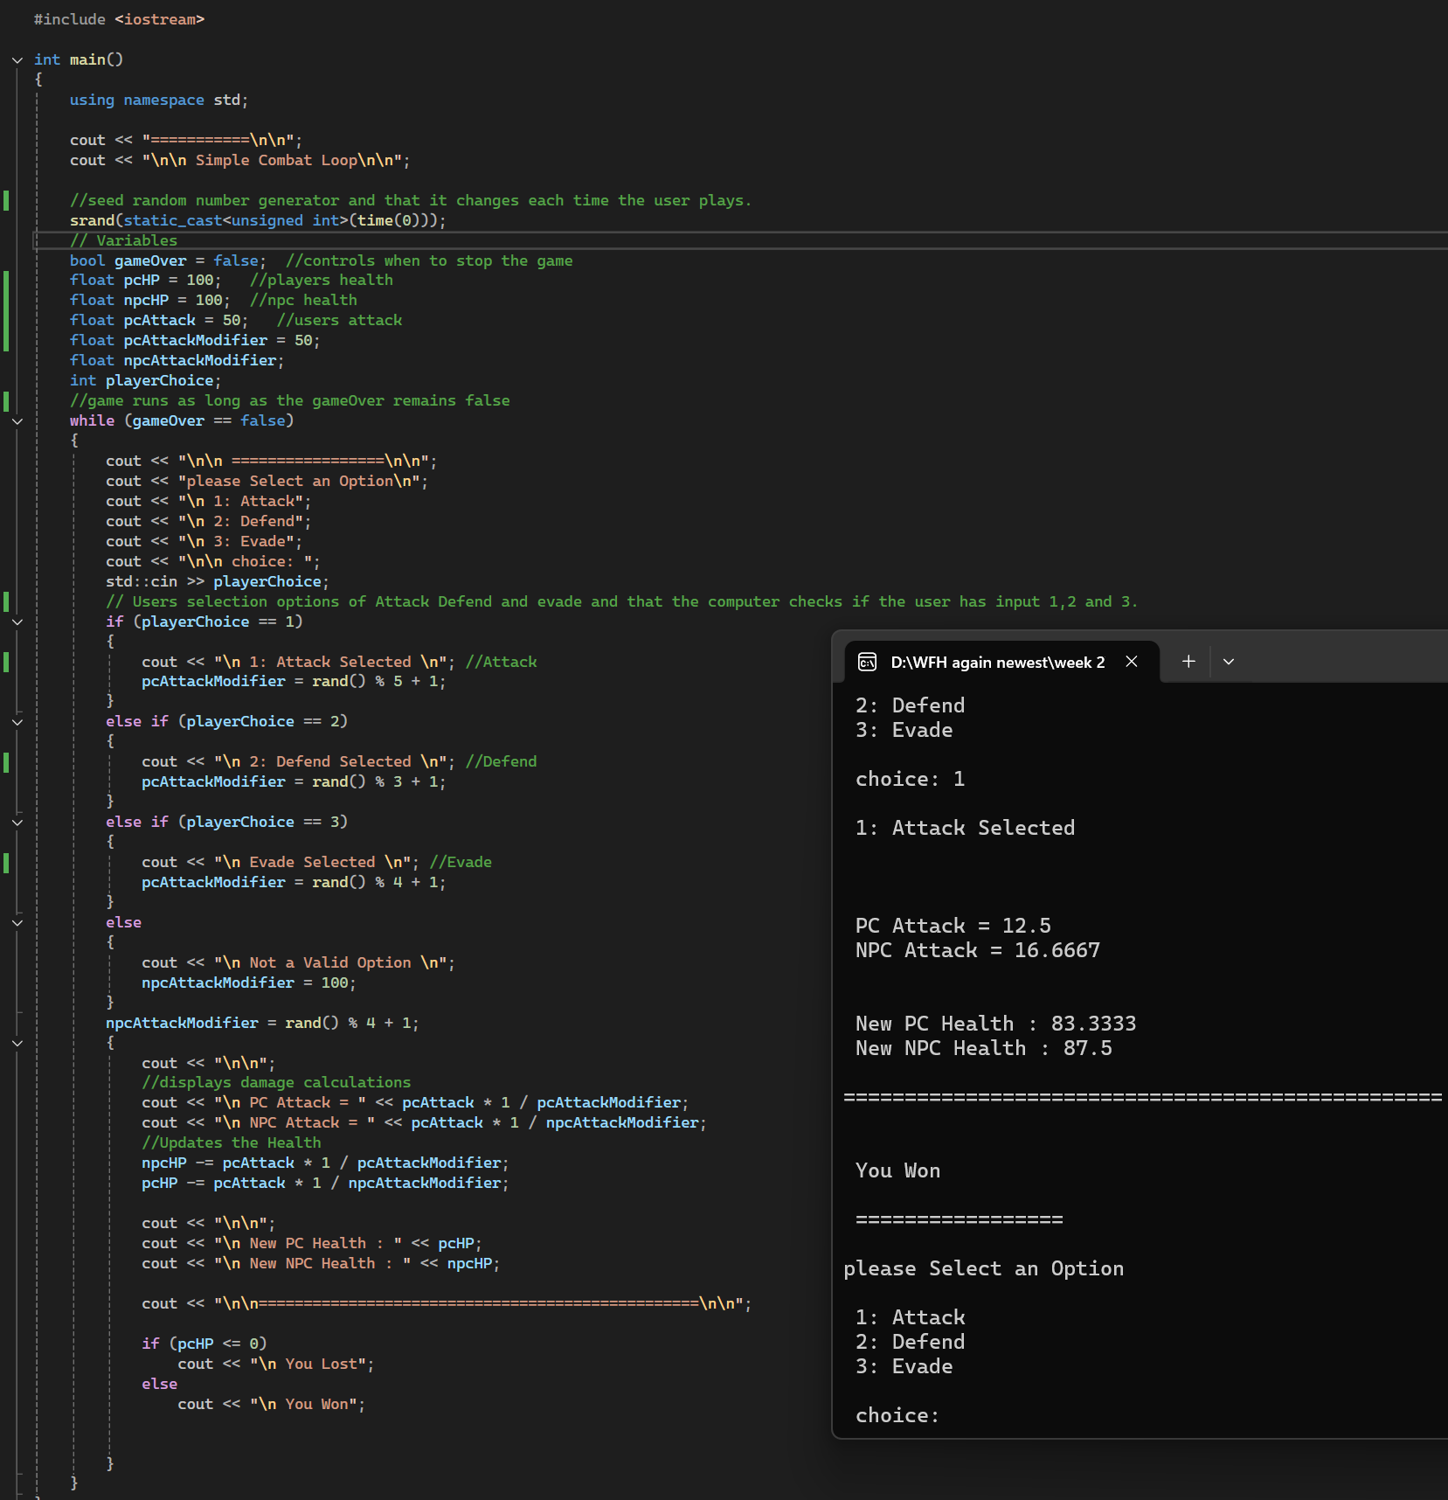
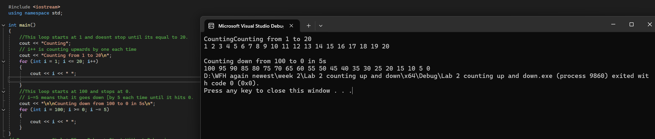
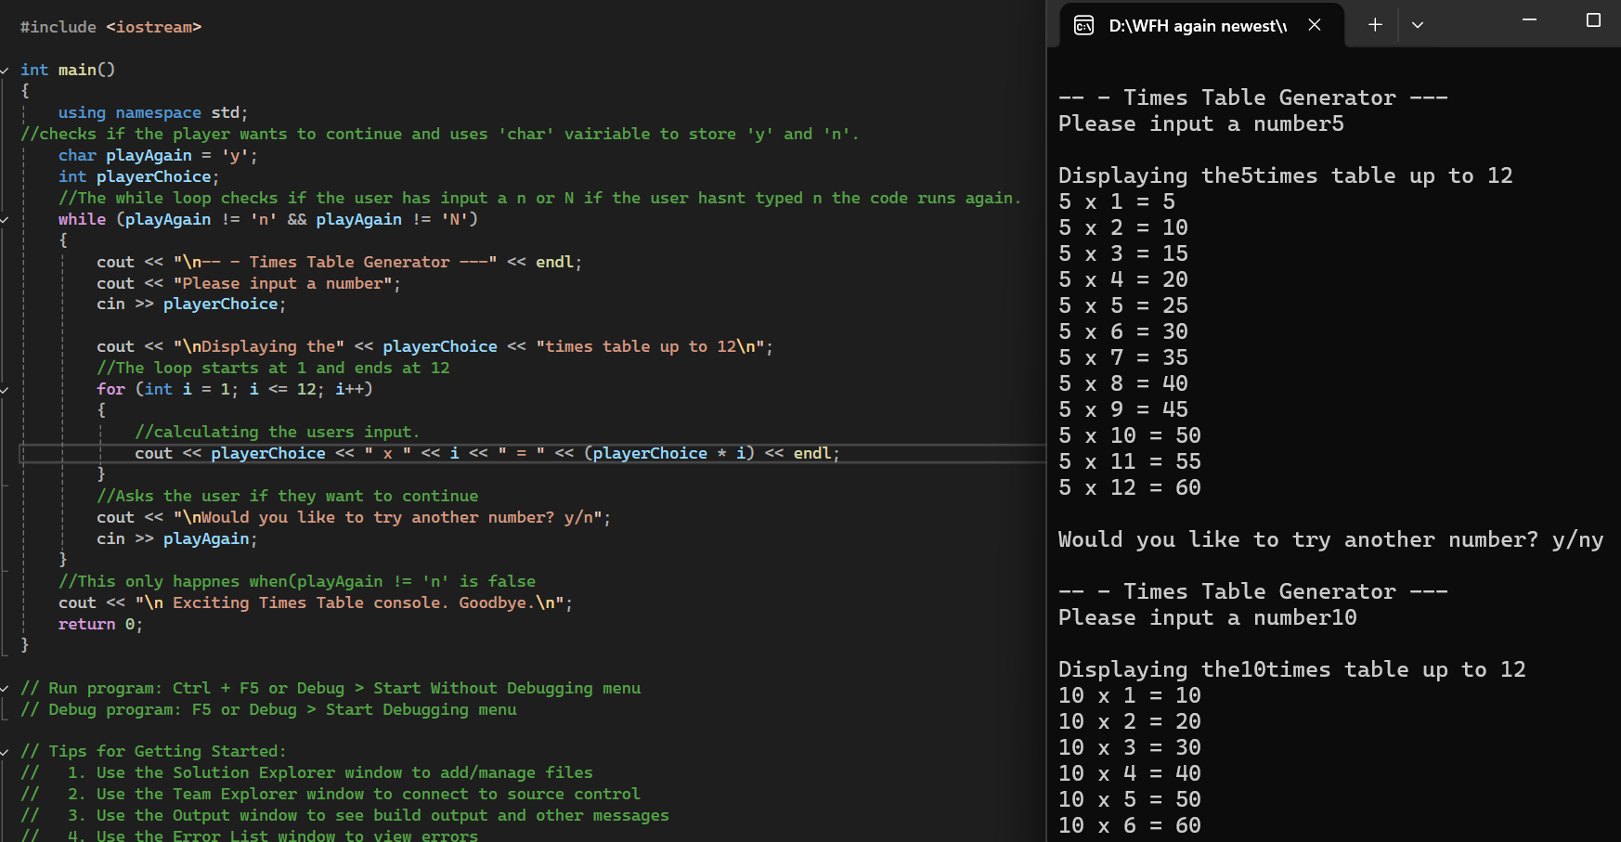

Lab 3 Functions
• What has been learnt from the process?
This was the first time using things like functions and I did do measurements with units before for example with the missile calculations however this is at a higher level while including things such as floats , const and Pythagoras with the sqrt code.
• What could you have done better?
I feel like the console is very condensed with how it looks with the numbers next to the letters in the console so that would mean implementing more \n.
• How can you use what you have learnt in making future games?
I feel like this code can be used in things like creating a barrier where the player is limited to movement or at least getting a debuff while staying out the specific zone.

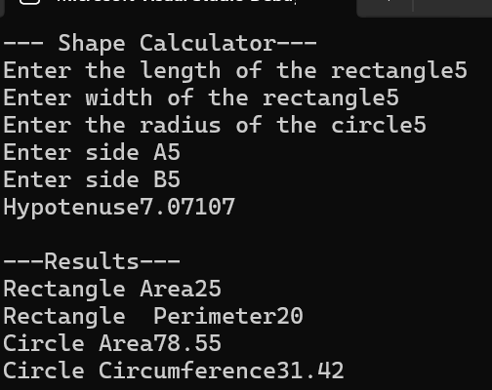
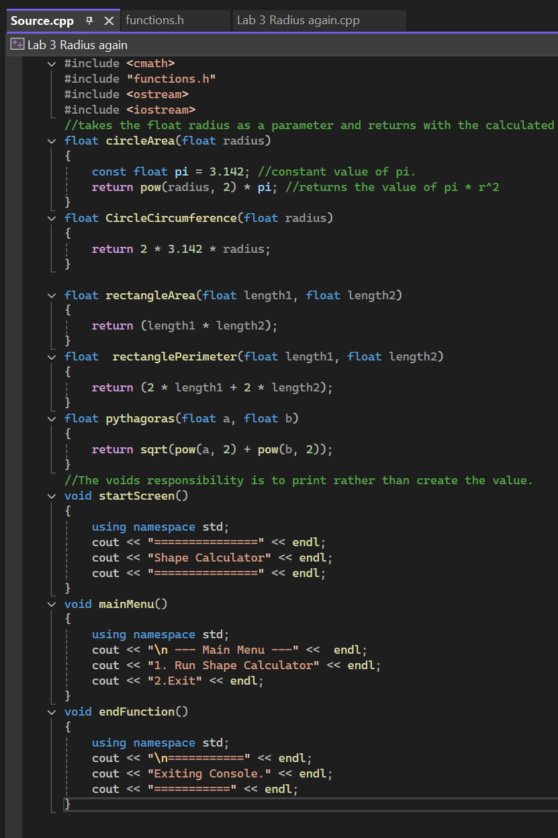

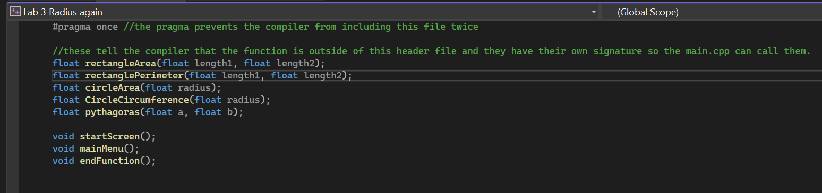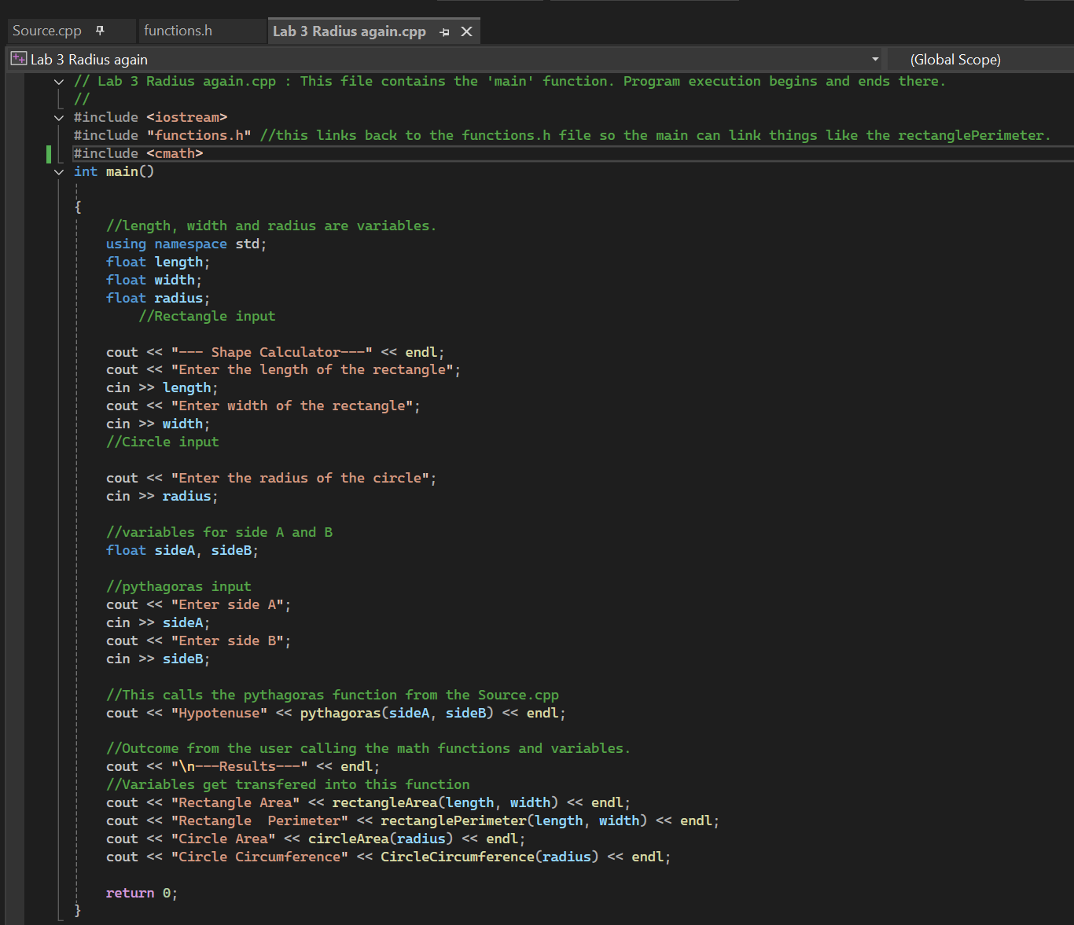
Lab 4 Arrays
- Brief overview of what you have done this Workshop:
- Created a Array table what had a random structure with what symbols will be used when the user inputs a random character onto the table.
- What has been learnt from the process?
Ive learnt how to create a table by using code like int h = (rand() % (boardHeight - 2)) + 1; however its important still to be careful of syntax errors when working on a large visual studios document.
- What could you have done better?:
The main one being the table and maybe I could of add more areas where the user is able to input more characters.

- How can you use what you have learnt in making future games?:
I feel like this type of game can be used in like a arcade version of a whack a mole where the user has to find where the coordinates are of the mole for example.
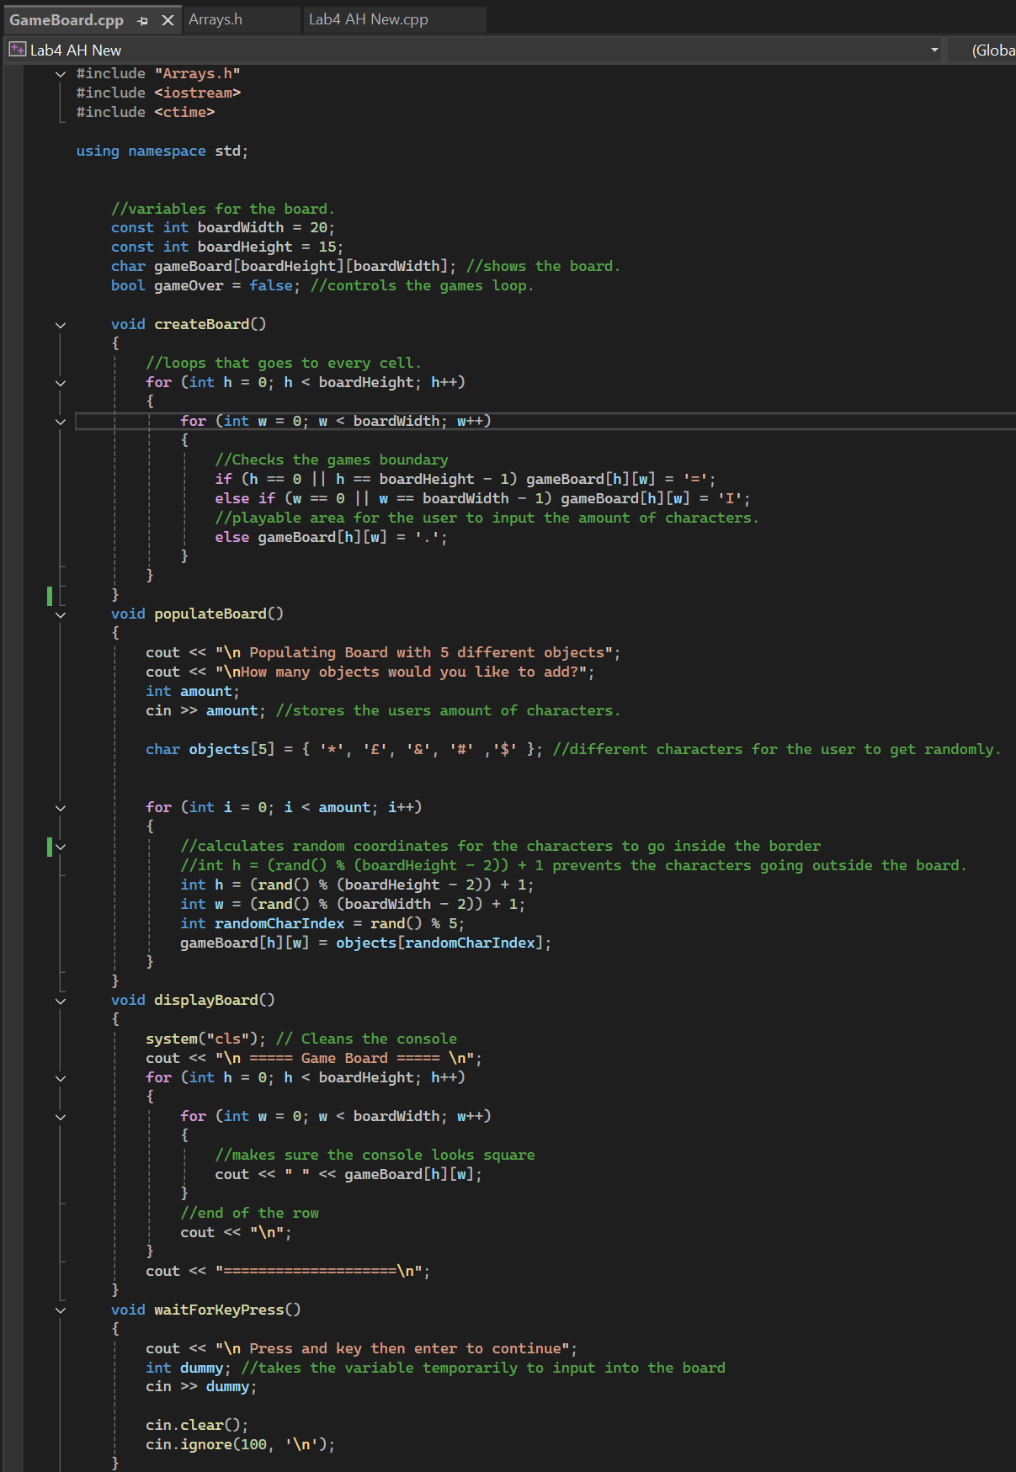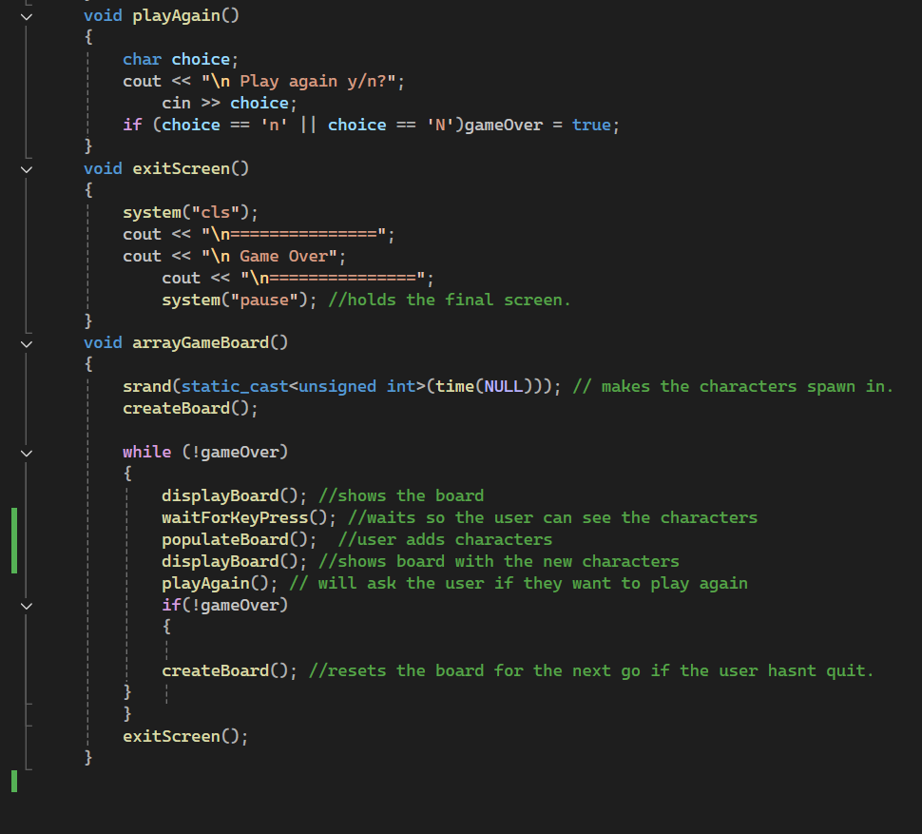

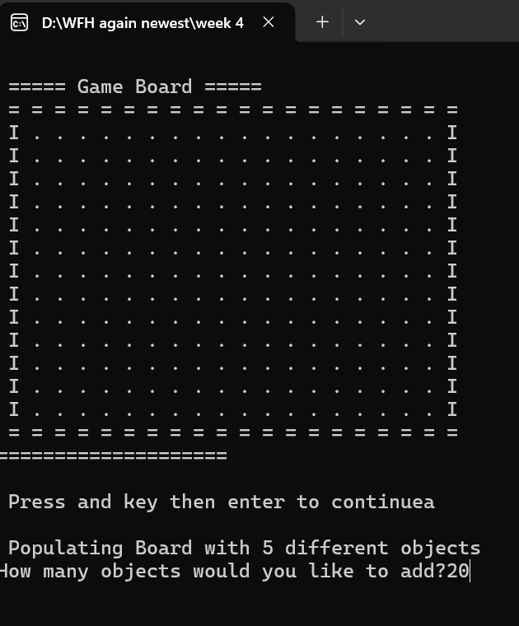
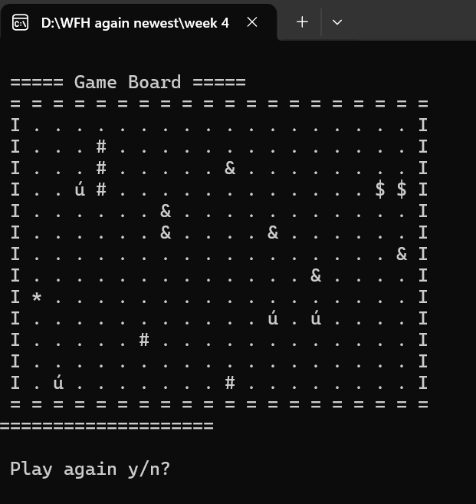

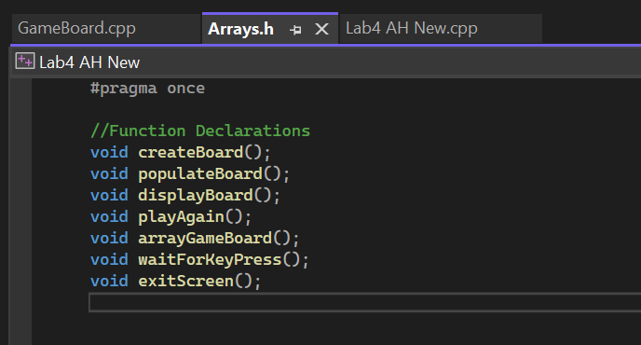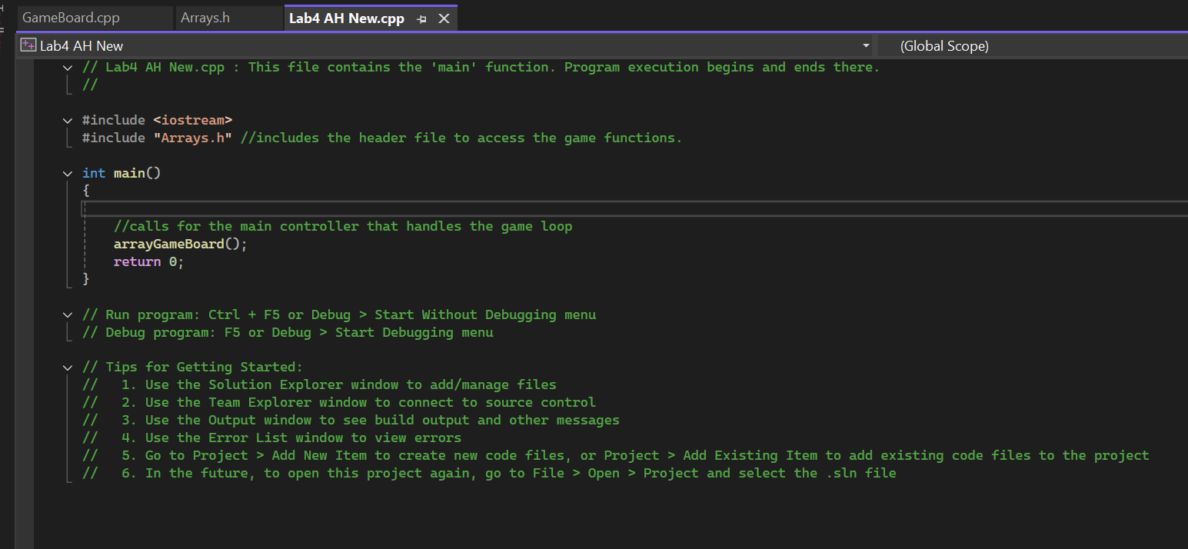

Lab 5 Objects
- Brief overview of what you have done this Workshop:
In the workshop I completed Objects with character stats and used public and private classes to separate each other
- What has been learnt from the process?
This was the first time learning to use public and private objects so It was a bit confusing starting off with.
- What could you have done better?:
That I could eventually make the shape calculations intractable where the user can decided what figures the user wants to use.
- How can you use what you have learnt in making future games?:
Public and Private is really important in games to separate what is so special about a character like you wouldn’t expect a support class doing as much damage as a damage class.

